***PAAREES PERFUMES***

***DAVIDOFF***

***FOR MEN***

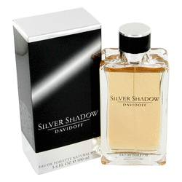

***Silver Shadow***

***Description:***

Silver Shadow by Davidoff Cologne. Show off your flair for luxury with Silver Shadow, a rich men's scent from Davidoff. Created in 2005, this fragrance has an undeniably masculine aroma. Inspired by untamed wilderness, this scent blends the richness of Virginia cedar with earthy patchouli. Delicious notes of saffron and coriander add a punch of warmth, while a splash of bitter orange brings in just enough bite to keep things fresh. A versatile composition, this scent is great for day or night.